Shape Up! 3 Create the home page

In this exercise, you’ll code the HTML for the home page. When you’re through, the page should look like this:

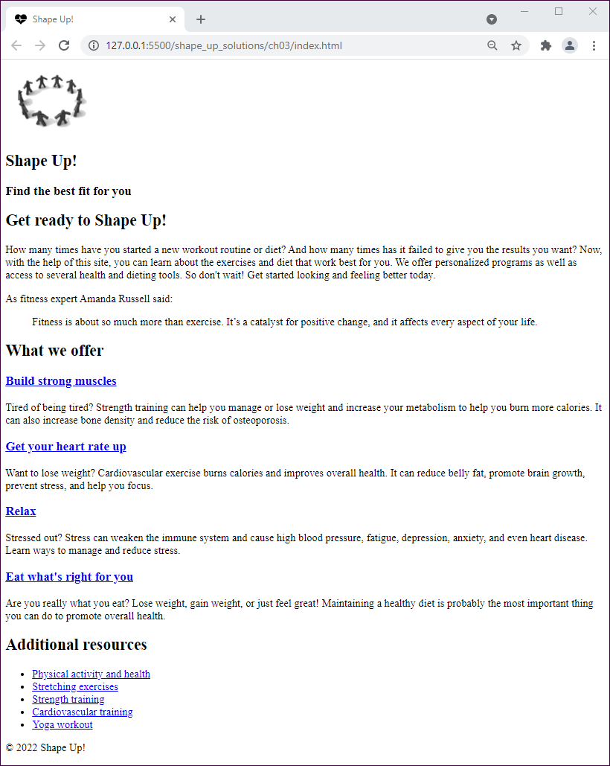

Specifications

* Create the home page from the index.html file that’s in the root folder for the website. This file includes just the basic HTML elements.
* Use the HTML semantic elements to structure the page so it includes a header, the main content with a section and a sidebar, and a footer.
* Add an image and two levels of headings to the header. You’ll find the image, named shape_up_logo.png, in the images folder. You’ll find the text for the header as well as for the other areas of the page in the home.txt file in the text folder.
* Add three levels of headings and the required text for the section content, which should include everything in the main element except for the additional resources. The level-3 headings should contain links to other pages named index.html that can be found in the strength, cardio, stress, and diet folders.
* Code the quote in the second paragraph of text as a block quote.
* Add a heading for the additional resources, and code the additional resources as an unordered list with links to the external pages that you locate.
* Add the required text to the footer, using a character entity for the copyright symbol.
* Add the link element for the favicon to the head element of the HTML document. You’ll find the favicon in the images folder.